Below is a standard operating procedure (SOP) for managing self-service password reset, account unlocking, and password changes.

Self-Service Password Reset (SSPR), Account Unlock, and Password Change SOP

Prerequisites:
  - Users must have registered their authentication methods on Google authenticator and Microsoft authenticator for SSPR.

Procedure:-

1. Self-Service Password Reset (SSPR):
Access the SSPR Portal:
  - Users can access the SSPR portal via a web browser.
  - URL: [https://selfservice.eurekaforbes.co.in/authorization.do]
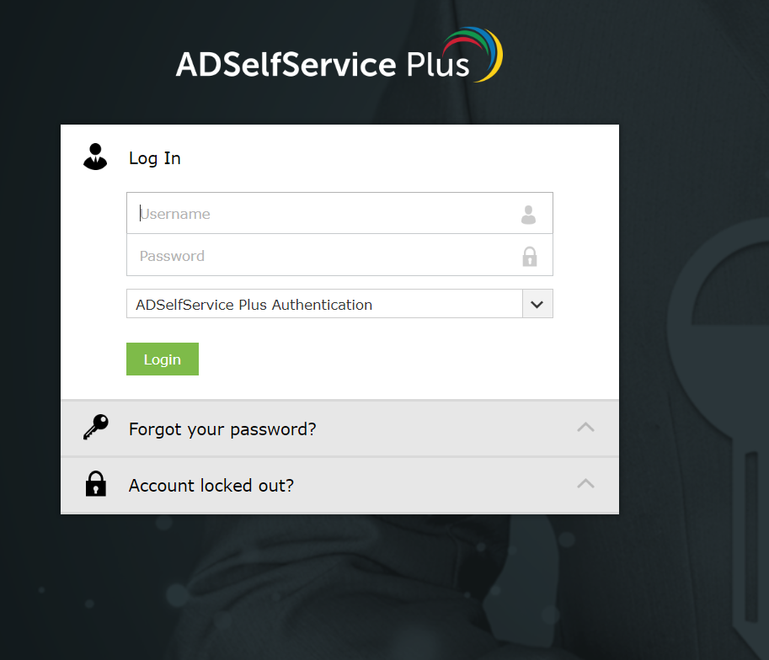
User Authentication:
  - Enter the following details:
    - User ID (firstname.lastname)
    - Google/Microsoft authenticator code
    - Captcha verification
  - The system will verify the user's identity.
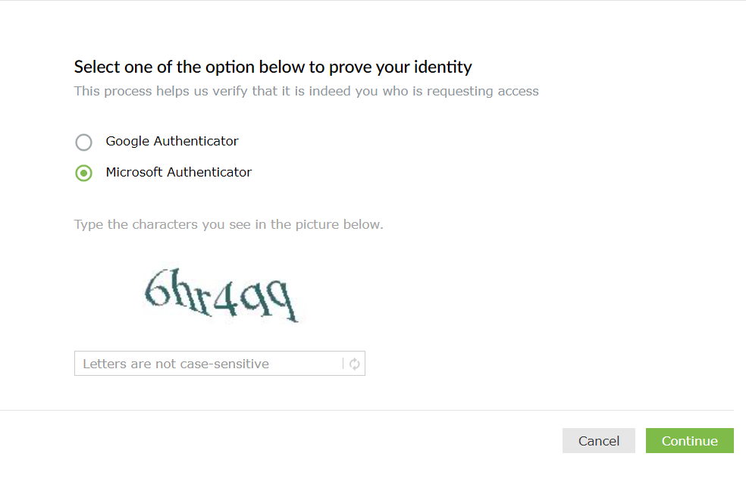
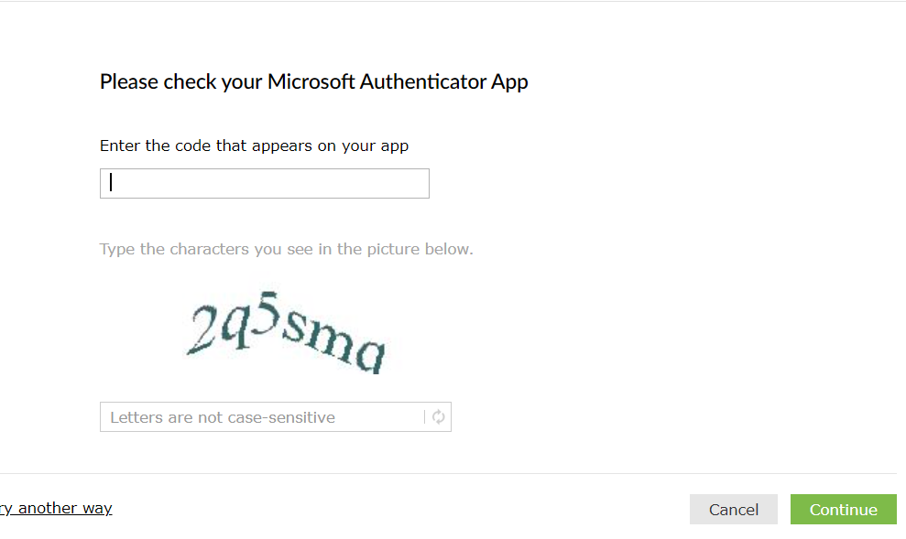
Password Reset:
  - If the user passes authentication, they can reset their password.
  - Follow the on-screen instructions to set a new password.

2. Account Unlock:
Access the Account Unlock Portal:
  - Users can access the account unlock portal via a web browser.
  - URL: [https://selfservice.eurekaforbes.co.in/authorization.do]
User Authentication:
  - Enter the following details:
    - User ID (email or username)
    - Google/Microsoft authenticator code
    - Captcha verification
  - The system will verify the user's identity.
Unlock the Account:
  - If the user passes authentication, they can unlocked his/her account.

3. Password Change:
Access the Password Change Portal:
  - Users can access the password change portal via a web browser.
  - URL: [https://selfservice.eurekaforbes.co.in/authorization.do]
User Authentication:
  - Enter the following details:
    - User ID (email or username)
    - Google/Microsoft authenticator code
    - Captcha verification
  - The system will verify the user's identity.
Change Password:
  - If the user passes authentication, they can change their password.
  - Follow the on-screen instructions to set a new password.

Troubleshooting:
- If users encounter issues during any of the above steps, they should contact the IT helpdesk for assistance on below,

022-48821770
✉ eflitservicedesk@eurekaforbes.com

